SMART WATER FOUNTAINS

Components required :

* Arduino UNO
* NodeMCU
* Gravity Analog pH sensor
* DS18B20 temperature sensor
* Soil moisture sensor
* Power supply
* Jumpers
* Breadboard
* Working of DS18B20 Temperature Sensor

**Datasets:**

Agriculture is the backbone of our country and it is very important to know the parameter of soil and water for efficient harvesting. The various parameters that can be monitored are Soil moisture, pH of water, Temperature, etc. We previously measured these parameters in different tutorials but today we will not only combining them but also display them on a webpage so that they can be monitored from anywhere in the world.

So before starting with this smart water quality monitoring system using Arduino project

**HARDWARE IMPLEMENTATION OF THE PROPOSED MODEL**

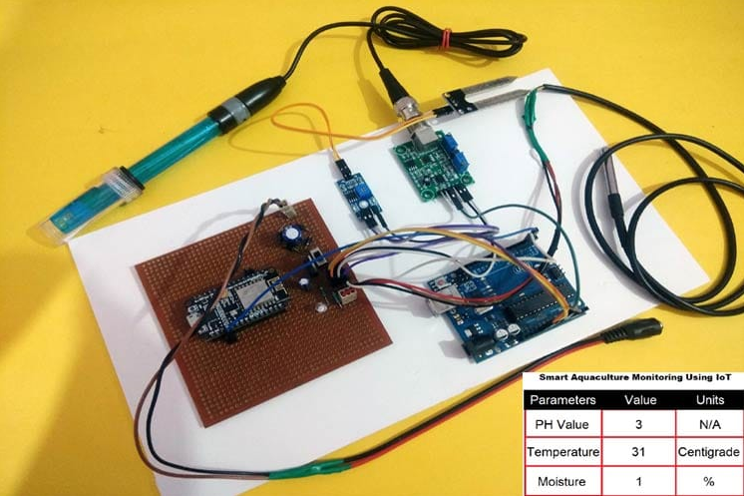

**Arduino UNO:**

is a low-cost, flexible, and easy-to-use programmable open-source microcontroller board that can be integrated into a variety of electronic projects. This board can be interfaced with other Arduino boards, Arduino shields, Raspberry Pi boards and can control relays, LEDs, servos, and motors as an output.

**NodeMCU**

The main use of NodeMCU is to create IoT projects that require wireless connectivity. It can be used to build smart home devices, remote sensors, data loggers, and other internet-enabled devices.

**Gravity Analog pH Sensor**

DFRobot's Gravity: Analog pH meter V2 is specifically designed to measure the pH of a solution and reflect it's acidity or alkalinity. This sensor is commonly used in various applications such as aquaponics, aquaculture, and environmental water testing.

**DS18B20 Temperature sensor**

This sensor is extensively used to calculate temperature within rigid environments which includes mines, chemical solutions, otherwise soil, etc. This sensor is used to measure the liquid temperature. We can use it in the thermostat controls system.

**power supply**

A power supply unit is used to provide stable electricity. The device converts and supplies electricity of the required voltage and frequency, excluding noise from the electricity obtained from an electrical outlet.

**Soil moisture sensors**

Soil moisture sensors measure or estimate the amount of water in the soil. These sensors can be stationary or portables such as handheld probes. Stationary sensors are placed at the predetermined locations and depths in the field, whereas portable soil moisture probes can measure soil moisture at several locations.

**jumper**

In electronics and particularly computing, a jumper is a short length of conductor used to close, open or bypass part of an electronic circuit. They are typically used to set up or configure printed circuit boards, such as the motherboards of computers.

**breadboard**

A breadboard (sometimes called a plugblock) is used for building temporary circuits. It is useful to designers because it allows components to be removed and replaced easily. It is useful to the person who wants to build a circuit to demonstrate its action, then to reuse the components in another circuit.

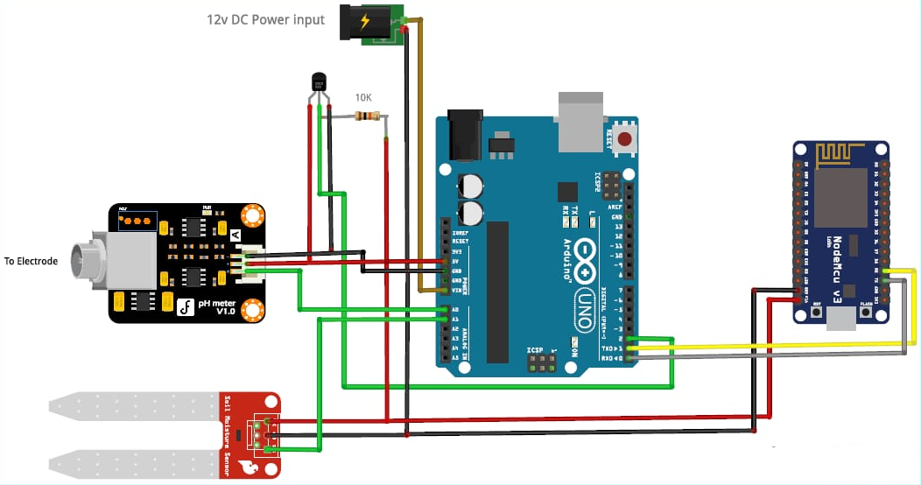

**Application:**

* An water fountain can also help your indoor plants by adding extra humidity that is lost when heat or air conditioning units are running.
* Negative Ions.
* In today's electronic world there are many gadgets that emit negative ions in our homes and offices.
* Drinking Source for Pets.
* Drowning Out Annoying Sounds.
* Water fountains are key decorative elements, but they also bring many benefits to the overall feel of the home according to the principles of Vastu Shastra.
* They help to cleanse water, give you splendid sights and sounds to enjoy & make your home more peaceful and relaxing.



**Future scope:**

Water fountains are key decorative elements, but they also bring many benefits to the overall feel of the home according to the principles of Vastu Shastra. They help to cleanse water, give you splendid sights and sounds to enjoy & make your home more peaceful and relaxing.